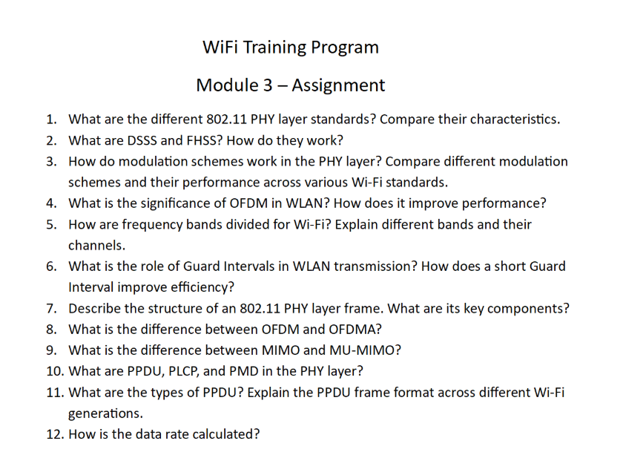
Wi-Fi Training Program
Assignment – Module 3

1. Different 802.11 PHY Layer Standards and Comparison
The Physical (PHY) layer defines how data is transmitted over the wireless medium using radio signals, modulation, and coding techniques.
Standard | Band | Max Data Rate | Modulation | Key Features
802.11b | 2.4 GHz | 11 Mbps | DSSS | Good range, low speed
802.11a | 5 GHz | 54 Mbps | OFDM | Less interference
802.11g | 2.4 GHz | 54 Mbps | OFDM | Backward compatible
802.11n | 2.4/5 GHz | 600 Mbps | OFDM + MIMO | Multiple streams
802.11ac | 5 GHz | ~6.9 Gbps | OFDM + MU-MIMO | Wider channels (80/160 MHz)
802.11ax | 2.4/5/6 GHz | ~9.6 Gbps | OFDMA | High efficiency, dense environments
Explanation:
Each new standard improves throughput, spectral efficiency, and reliability using advanced techniques like MIMO, channel bonding, and OFDMA.

2. DSSS and FHSS
DSSS (Direct Sequence Spread Spectrum):
- Data is multiplied with a spreading code (chipping sequence)
- Spreads signal over a wider bandwidth
- Receiver uses same code to recover data
- More resistant to noise and interference
FHSS (Frequency Hopping Spread Spectrum):
- Signal rapidly hops between frequencies
- Uses predefined hopping sequence
- Reduces interference and improves security
Working Principle:
Both techniques spread the signal to reduce interference, but DSSS spreads across all frequencies simultaneously, while FHSS jumps between frequencies.

3. Modulation Schemes in PHY Layer
Modulation converts digital data into radio signals.
Scheme | Bits per Symbol | Characteristics
BPSK | 1 | Very robust, low speed
QPSK | 2 | Balanced performance
16-QAM | 4 | Higher data rate
64-QAM | 6 | Used in 802.11n/ac
256-QAM | 8 | High throughput (Wi-Fi 5/6)
Explanation:
Higher-order modulation increases data rate but requires better signal quality (higher SNR). In poor signal conditions, systems fall back to lower modulation schemes.

4. Significance of OFDM in WLAN
OFDM (Orthogonal Frequency Division Multiplexing) divides a high-speed data stream into multiple low-speed subcarriers.
How it works:
- Data is split into parallel streams
- Each stream is transmitted on separate subcarriers
- Subcarriers are orthogonal (no interference)
Advantages:
- Reduces multipath interference
- Increases spectral efficiency
- Supports high data rates
Explanation:
OFDM is the backbone of modern Wi-Fi standards because it efficiently utilizes bandwidth and performs well in indoor environments.

5. Wi-Fi Frequency Bands and Channels
2.4 GHz Band:
- Range: Long
- Channels: 1–14 (only 3 non-overlapping: 1, 6, 11)
- More interference (Bluetooth, microwaves)
5 GHz Band:
- Range: Medium
- Many non-overlapping channels
- Supports wider bandwidth (20/40/80/160 MHz)
6 GHz Band (Wi-Fi 6E):
- High capacity, low interference
- Large number of channels
- Suitable for dense environments
Explanation:
Lower frequencies provide better coverage, while higher frequencies provide higher speeds.

6. Guard Intervals in WLAN
Guard Interval (GI) is a time gap between OFDM symbols.
Purpose:
- Prevents Inter-Symbol Interference (ISI)
- Handles signal reflections (multipath)
Types:
- Long GI: 800 ns
- Short GI: 400 ns
Short GI Advantages:
- Higher data rate (~10% improvement)
- Better efficiency
Explanation:
Short GI improves throughput but may reduce reliability in environments with high interference.

7. Structure of 802.11 PHY Frame
An 802.11 PHY frame consists of:
- Preamble:
  - Used for synchronization
  - Helps receiver detect signal
- PLCP Header:
  - Contains data rate, length, and modulation info
- Payload (PSDU):
  - Actual MAC layer data
Explanation:
The PHY frame ensures proper transmission and decoding of wireless signals.

8. Difference between OFDM and OFDMA
Feature | OFDM | OFDMA
Users | Single user | Multiple users
Channel Use | Full channel per user | Subcarriers shared
Efficiency | Lower | Higher
Used in | Wi-Fi 4/5 | Wi-Fi 6
Explanation:
OFDMA divides subcarriers among multiple users, improving performance in high-density networks.

9. MIMO vs MU-MIMO
MIMO (Multiple Input Multiple Output):
- Multiple antennas used
- Improves speed for a single user
MU-MIMO (Multi-User MIMO):
- Multiple users served simultaneously
- Improves network capacity
Explanation:
MU-MIMO allows parallel communication, reducing congestion and improving efficiency.

10. PPDU, PLCP, and PMD
- PPDU: Complete PHY frame transmitted over air
- PLCP: Adds header and prepares data for transmission
- PMD: Handles actual radio transmission
Explanation:
These components ensure proper interaction between MAC and physical transmission.

11. Types of PPDU
- Legacy PPDU: For older standards
- HT PPDU: Used in 802.11n
- VHT PPDU: Used in 802.11ac
- HE PPDU: Used in 802.11ax
Explanation:
Each PPDU format is optimized for its respective Wi-Fi generation.

12. Data Rate Calculation
Data rate depends on:
- Channel bandwidth
- Modulation (bits per symbol)
- Coding rate
- Number of spatial streams
- Guard Interval
General Formula:
Data Rate = (Subcarriers × Bits per Symbol × Coding Rate × Streams) / Symbol Duration
Explanation:
Higher bandwidth, higher modulation, and more spatial streams result in increased data rates.

